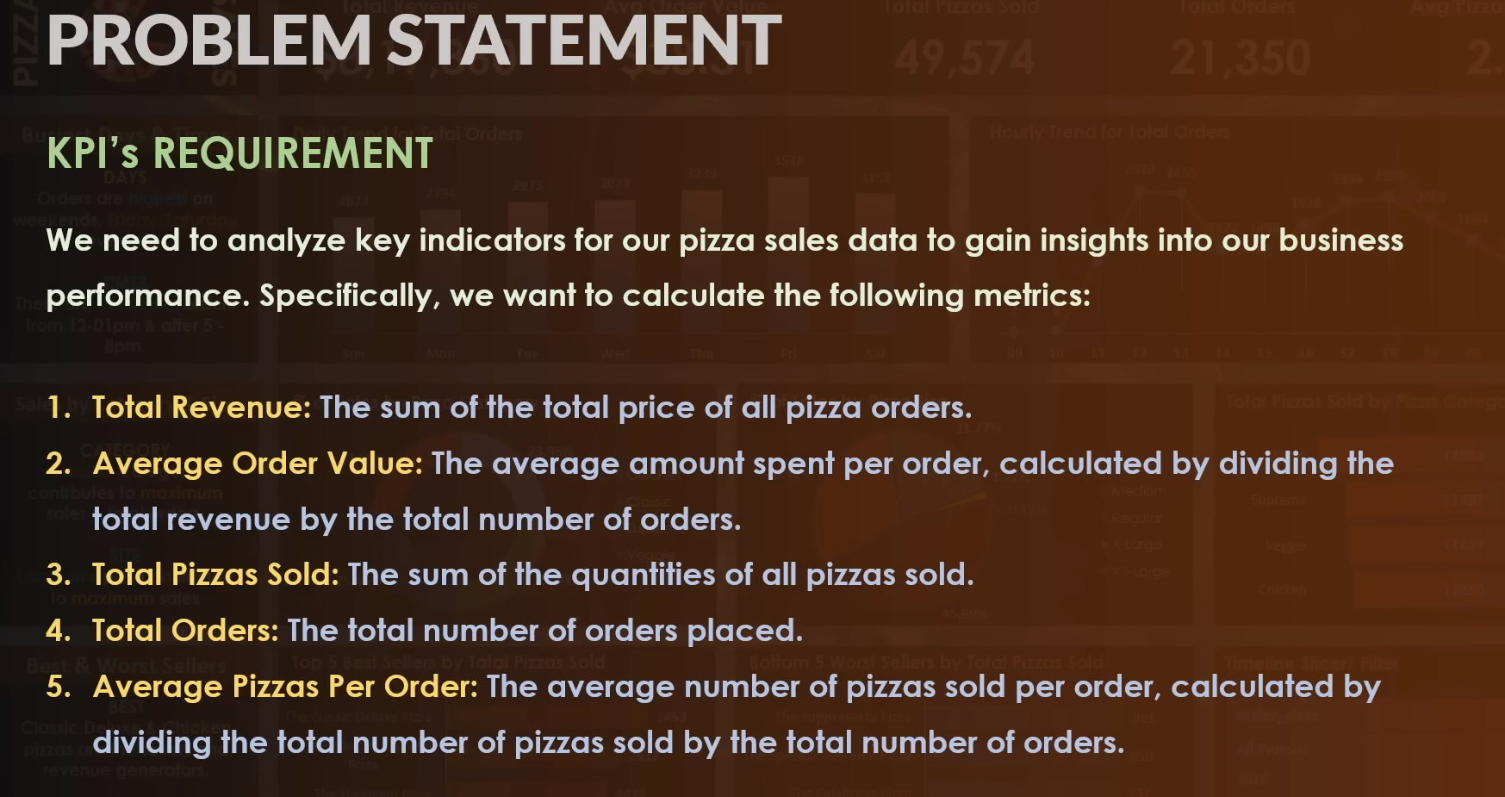  
  
  
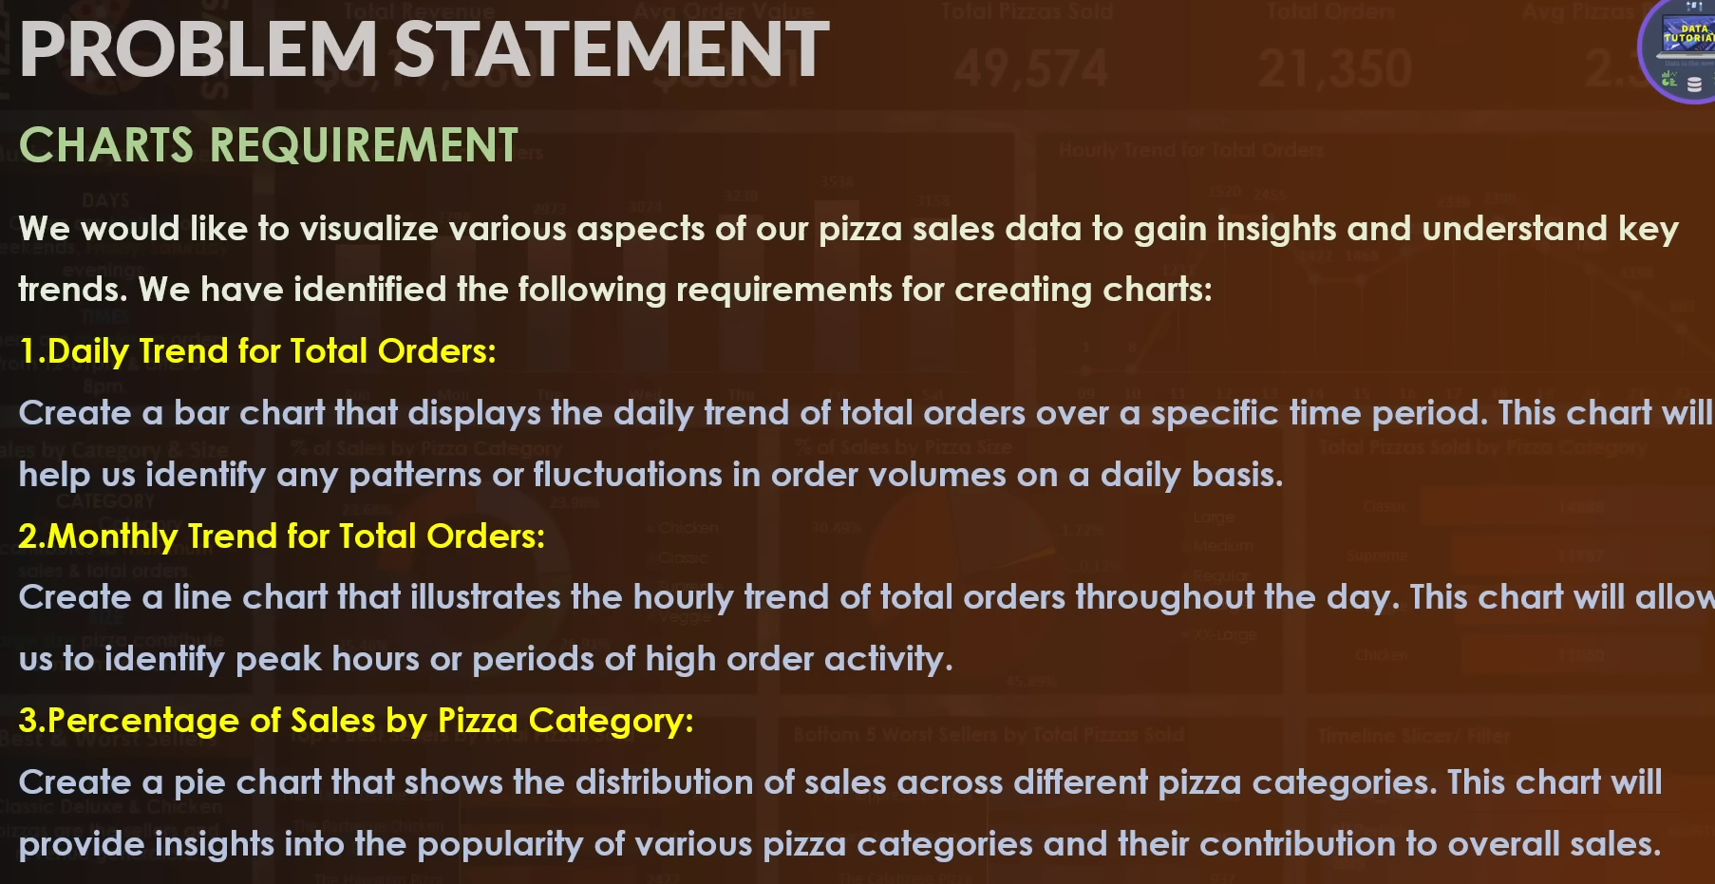  
  
  
  
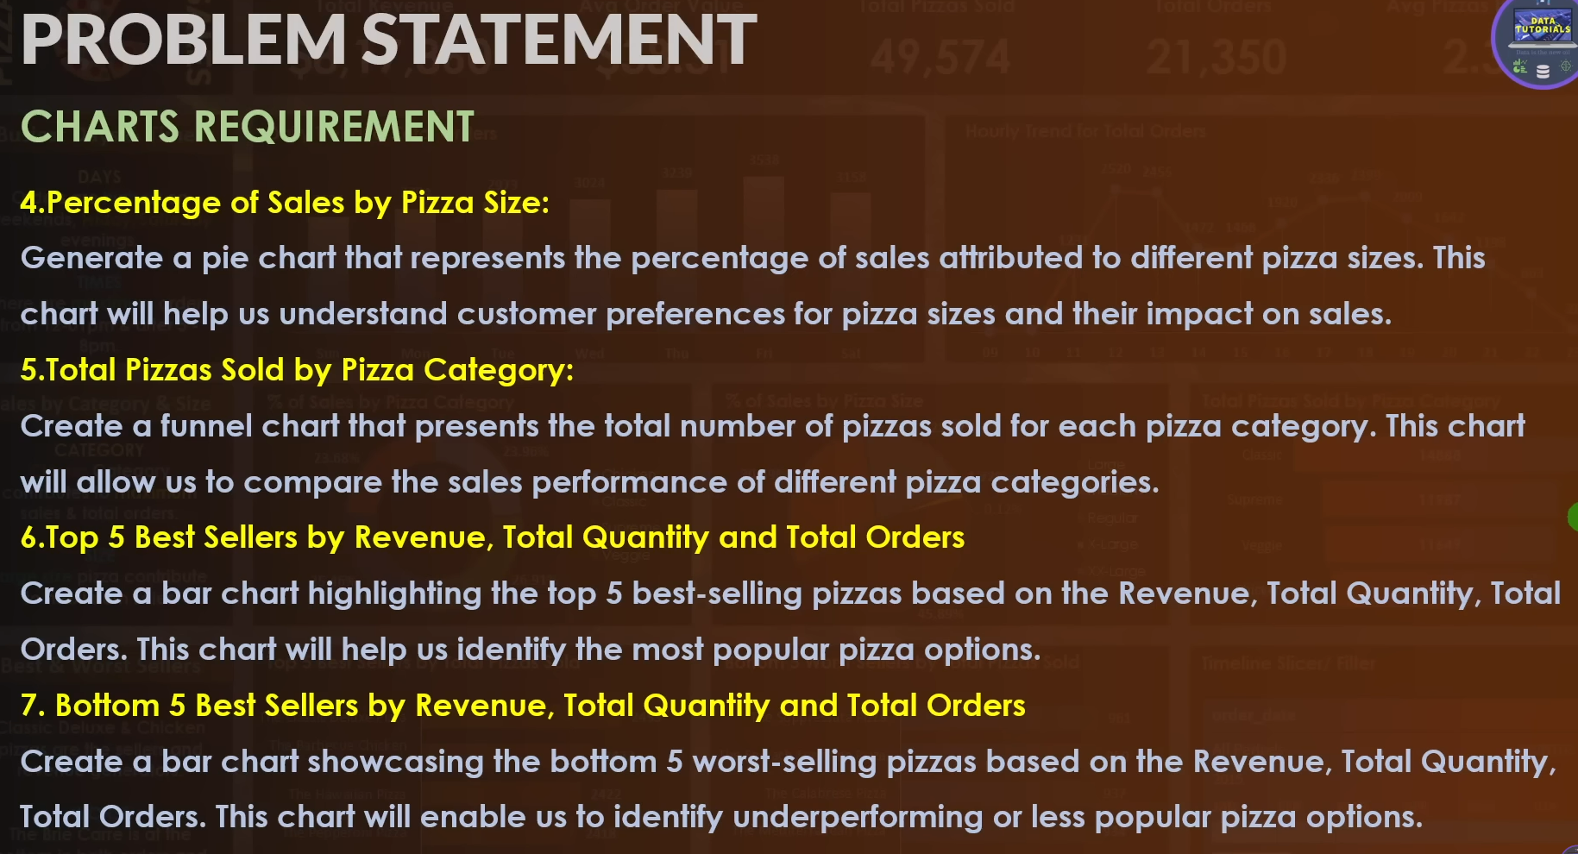  
  
  
  
  
  
KPIs  
  
1. Total Revenue  
select ROUND(SUM(total_price), 2) from pizza_sales  
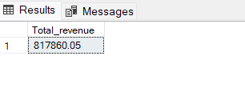  
  
2. Average Value  
select ROUND(SUM(total_price) / COUNT(DISTINCT(order_id)), 2) as Average_value

from pizza_sales

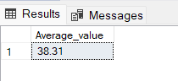

3. Total Pizza sold

select sum(quantity) as Total_pizza_sold from pizza_sales  
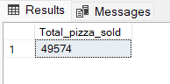

4. Total Orders

select count(distinct(order_id)) as total_orders from pizza_sales  
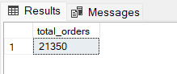  
  
5. Avg pizza sold per order  
select CAST(CAST(sum(quantity) as decimal(10,2)) / count(distinct(order_id)) as decimal(10,2)) as Avg_pizza_per_order from pizza_sales

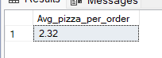  
  
  
  
  
Chart Requirements  
1. Daily Trend for Total orders.

select DATENAME(DW, order_date) as order_day, count(distinct(order_id)) as Total_orders

from pizza_sales

group by DATENAME(DW, order_date)

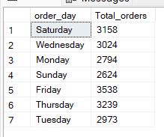

2. Monthly Trend  
select DATENAME(MONTH, order_date) as order_day, count(distinct(order_id)) as Total_orders

from pizza_sales

group by DATENAME(MONTH, order_date)

order by Total_orders desc;

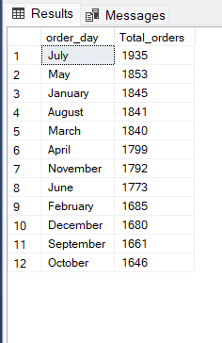

3. Percentage of Sales by Pizza Category

select pizza_category, sum(total_price) as Total_Sales, sum(total_price) * 100 /

(select sum(total_price) from pizza_sales) as PCT

from pizza_sales

group by pizza_category

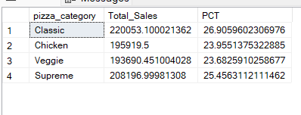  
  
  
4. Percentage of Sales by Pizza size  
select pizza_size, sum(total_price) as Total_Sales, CAST(sum(total_price) * 100 /

(select sum(total_price) from pizza_sales) as decimal(10,2)) as PCT

from pizza_sales

group by pizza_size

Order by PCT desc  
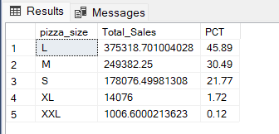  
  
  
  
5.

6. Top5 pizza   
select TOP 5 pizza_name, sum(total_price) as Total_Revenue

from pizza_sales

group by pizza_name

order by Total_Revenue desc

